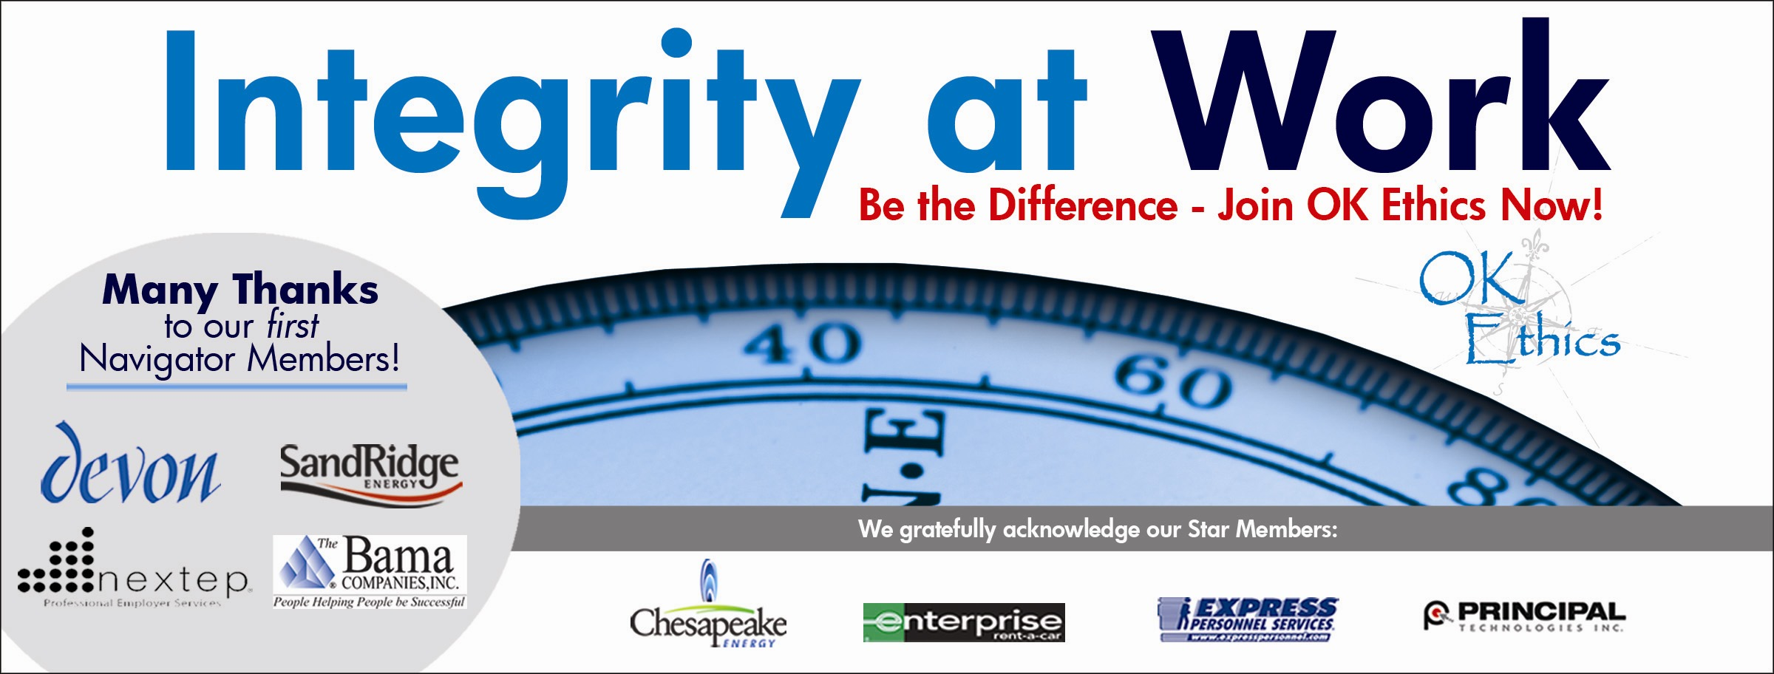

Oklahoma Business Ethics Consortium
Tulsa Chapter

March 27, 2008 – 11:30 a.m. to 1 p.m.

- Welcome and special recognition (11:45 -11:50) John Stancavage, Tulsa World
Special thanks to OkEthics members Nick Minden, Michael Oonk, Carol Swarthout, Jana P. Momeni, Lynn Flinn and Jenny Lizama for their help with this meeting.

II. Guiding Principle (11:50 – noon) Nick Minden, Hogan Assessment Systems
The Oklahoma Business Ethics Consortium’s activities are conducted under a set of guiding principles.

III. Introduction of guest speaker (Noon John Stancavage

IV. Keynote address: Rick Brinkley, president and CEO, Better Business Bureau (Noon – 12:50)

A former Emmy-nominated producer of the Sally Jessy Raphael show in New York City, Brinkley currently travels throughout the nation as a speaker, conference leader and lecturer. His career in television has allowed him to serve as a consumer reporter, investigative producer, talk show producer, writer and on-air personality. Rick holds a bachelor of arts degree from Langston University and a master’s degree from the Oral Roberts University School of Theology and Missions. Currently, Rick is president and CEO of the Better Business Bureau of Eastern Oklahoma.

V. Membership update OK Ethics Legacy Team

VI. Closing remarks (1 p.m.) John Stancavage

Ok Ethics

UPCOMING EVENTS

Tulsa Chapter

- April – No chapter meeting. OK Ethics Compass Awards in Oklahoma City, April 28.
- May 27 – Panel discussion: “How Good Organizations Turn Evil”
- June 26 – Clifton L. Taulbert, president and founder, The Building Community Institute.

OKC Chapter

- April – No chapter meeting. OK Ethics Compass Awards in Oklahoma City, April 28, featuring former Oklahoma Gov. George Nigh.
- May 14 – Panel discussion: Oklahoma Attorney Generals.

To register for a Tulsa event, or see a list of Oklahoma City or Norman chapter meetings, go to our Web site at www.okethics.org

PLEASE HELP US CONTROL COSTS BY LEAVING YOUR NAME TAG HERE!

NOTE: Members of the Oklahoma Business Ethics Consortium frequently share information concerning various issues and developments that may have legal implications. The discussions, commentary, and handouts at Consortium meetings or presentations to other organizations are for general informational purposes only. They cover only some aspects of the subject topic, and do not constitute a complete legal analysis of the topic or how it might apply to any particular set of facts. Before taking any action based on information presented by a Consortium member, participants are encouraged to consult a qualified attorney. The observations and comments of presenters at Consortium meetings and networking are the views and opinions of the presenter and do not constitute the opinion or policies of the Consortium or any of its members. Please note that speakers are advised in advance of OkEthics policy against politicking, preaching, self-promotion and profanity.

OkEthics

We always are seeking new members.

Join today – You can make a difference!

Corporate Level
NAVIGATOR – $7,500 Includes 16 memberships; prepaid for all OkEthics events – including annual Compass Award

STAR – $5,000 Includes 8 memberships; prepaid for all OkEthics events – including annual Compass Award

HORIZON – $2,500 Includes 8 prepaid meals

LEADING – $1,200 Includes 2 prepaid meals

FRONTIER – $350 Includes 8 memberships; no meals

Individual Level

Trailblazer = $500 (Includes 1 prepaid meal)

Scout = $75 (Individual membership, no meals)

For more information on membership, go to www.okethics.org

